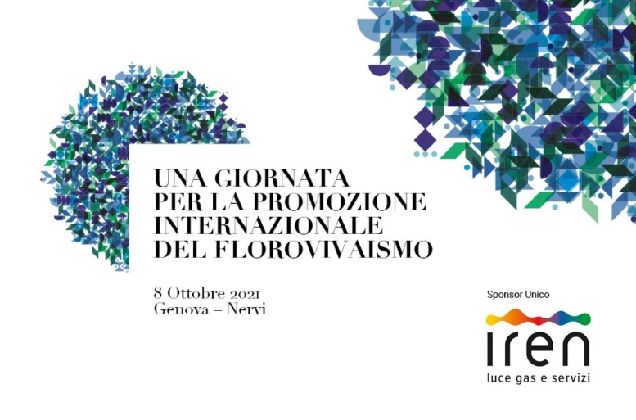

Genoa, 8th October 2021
Press release

Waiting for Euroflora 2022

Euroflora 2022 at the centre of important international circuits

Throughout the world it’s a “Plantdemic”, the desire for green grows,
for green cities and life in the open air and for floriculture it’s a boom

Research and experiments paying special attention to sustainability for both producers and users

The Floriculture Bill of Law is working to reconfirm the green bonus and the “scrapping” of greenhouses

A desire for Euroflora, for all that's green, green cities, life in the open air in Italy and in the rest of the world. To substantiate this trend, data and investigations on hand, we have the confirmation by some of the most acclaimed Italian and foreign experts who met today here in Genoa during the day devoted to the international promotion of floriculture, organised by Porto Antico and sponsored by IREN, in the framework of “Waiting for Euroflora 2022”.

Tim Briercliffe, Secretary General of AIPH, the International Association of Horticultural Producers, that is the association that certifies international floralies, spoke of the “Power of plants” and of a keen desire for a greener world that has come to life during the Covid-19 pandemic, so widespread in fact that Australia christened it: “Plantdemic”. Mr. Briercliffe then dwelled on Euroflora's comeback to the circuit of the most important international floralies and of AIPH's commitment, with the Green City project, to communicate that these events convey a message that the wellbeing of people who live in big urban contexts goes hand in hand with a larger number of green areas open to the public. This is the direction that AIPH chose for this year's World Green City Award.

Great optimism came from Alberto Manzo's intervention, a floriculture expert part of MIPAAF – Ministry of Agricultural, Food and Forestry Politics, stemming from two significant figures: the growth of Italian exports and imports during the January-June 2021 period that showed a 33.14% and a 30.22% increase, respectively, if compared to the same period of the previous year. Furthermore, Mr. Manzo mentioned the contents of the Bill of Law on floriculture that is currently undergoing a parliamentary evaluation, and he mentioned the possibility of including funds to “scrap” existing greenhouses that in Italy are direly obsolete.

Mr. Leonardo Capitanio, President of ANVE – National Association of Exporter Growers – mentioned extremely positive figures: he spoke of a 40% growth in sales and a 50% growth in the overall production meant for foreign markets. Mr. Capitanio then underlined the capacity that every single Italian company has in researching new varieties, a characteristic that together with high quality makes Italian products greatly successful abroad.

According to Mr. Davide Michelini, vice-president of AICG – the association that groups more than 130 Garden Centres in Italy, companies specialised in retail selling of plants and all the pipeline's products, sometimes with their own production, the 2021 sales figures compared to 2019, according to the type of product, have marked an increase ranging from 10 to 25% with a continuous growth trend notwithstanding the worsened international economic situation and the price increase of raw materials and energy. Mr. Michelini pointed out that the average consumer has changed, is far more aware and prepared even though a neophyte. The boom has been for orchard seedlings and indoor plants, great growth for fruit trees and herbs, but also ornamentals of all types that have experienced a more than average interest.

The need to make the large public understand how complex floriculture is, according to Mr. Luca De Michelis, President of the Ligurian Floriculture District, is increasingly fundamental. The use of social networks, other communication means as well as “open days” in the grounds of nurseries are an effective tool to communicate how much research and innovation are present in this sector.

Holland's return, a sign that Euroflora is back in the centre of the international landscape, has been the focus of Mr. Nick Roozen's speech: he is one of the most celebrated Dutch landscape creators, designer of the coming Floriade 2022 edition as well as of the Netherland's participation here in Genoa. Mr. Roozen illustrated the Northern European past experiences of Floriade that – unlike floralies that are short-lived exhibitions – is an international expo that takes place once every 10 years, lasts between 3 to 6 months with the definitive greening of new urban areas carried out by the exhibiting nations.

Mr. Giovanni Minuto, general director of CeRSAA – Experimentation and Agricultural Assistance Centre – a centre of national excellence headquartered in Albenga, illustrated the technological innovations that allow floriculture in open air and greenhouses to reduce their environmental impact, to favour energy saving and to fight against pathogens while reducing the use of chemicals by employing a pre-defined wavelength in the new lighting systems. Ms. Valeria La Terra of Iren Smart Solutions presented a selection of actions that flower farms may adopt to improve energy efficiency, such as insulation and last generation heaters.

The Director of Euroflora, Mr. Rino Surace, extensively described the coming edition announcing some of the most significant international participations: the return of Holland and China, Russia's first time ever, the United States of America with the city of Columbus, Ohio, Spain with Murcia and last but not least the Principality of Monaco. Thailand and Ecuador are discussing their participation. The President of Porto Antico di Genova, Mr. Mauro Ferrando, spoke of Euroflora's role in the sector's development, of its relevance for new generations that find in Euroflora an opportunity to grow and consider how to disseminate an environmental culture. On this topic, Mr. Ferrando made an important disclosure: “The participation of the Ministry of Ecologic Transfer with Federparchi for the first time to the Genoese Show, setting up a tour through the national park's network with botanical endemisms and rarities explained with the help of virtual reality among other methods”. Mr. Ferrando then read the well-wishing message from the Minister for Agricultural Policy, Mr.Stefano Patuanelli, who underlined how the bill of law currently discussed on floriculture will put back into the limelight the re-confirmation of the “green bonus”.

In his greetings message, Mr. Carlo Ferro, President of the ICE Agency, recalled the Agency's engagement vis-à-vis Euroflora 2022 which entails organising two missions involving foreign operators to support the internationalisation of Made in Italy, highlighting how important it is for the Italian exhibitions and shows system and of the entire country to start anew.

The Mayor of Genoa, Mr. Marco Bucci, underlined the absolute modernity of the Euroflora format organised in the Nervi Parks and highlighted its importance for the city, like a rebirth sign, that will make Genoa the venue for hundreds of thousands of visitors. The Mayor then met with Mr. Tim Briercliffe to start a dialogue on the topic of “Green Cities”.

Mr. Giovanni Berrino, councillor in charge of tourism and important events for Regione Liguria, stated that: "Floriculture is for Liguria a vital production and occupation resource that also results in beauty. Our parks and gardens are an example. Liguria is green and blossoms in every season. Euroflora shall, as it traditionally has been doing, unite the enhancement of flower production and its touristic offer”. Mr. Luigi Attanasio, President of the Chamber of Commerce, guaranteed his support to Euroflora, a consolidated activity since decades, meant to enhance the economic aspects for producers and the outfall on the pipeline created by the massive presence of tourists.

Back to the Green Cities topic, Asproflor Comuni Fioriti, since years a partner of the Canadian Nursery Landscape Association https://cnla.ca/ and https://www.communitiesinbloom.ca/, - the associations that organise the worldwide “communities in flower” competition - is promoting for this year, too, the exclusive participation of Italian cities; Alba and Ingria shall represent the Italian flag in this 2021 floral competition.

The Minutes of this day as well as the original texts of the speeches may be downloaded from the site: www.euroflora.genova.it.

_____________________________________________________________
Ufficio stampa Porto Antico di Genova Spa
Giusi Feleppa 3357157199 – 010 2485675 gfeleppa@portoantico.it
www.euroflora.genova.it www.portoantico.it

